QCS
Regus House, Highbridge Industrial Estate, Oxford Road, Uxbridge, Middlesex, UB8 1HR, United Kingdom, Phone: TBA

Home Working Policy and Procedure
Category: Human Resources Sub-category: Contract of Employment

Policy Review Sheet
Page: 1 of 8 Last Reviewed: 10/03/2020 Last Amended: N/A

Last Reviewed: 16/03/20 Last Amended: N/A

Next planned review in 12 months, or sooner as required.

Business Impact: | Low | Medium | High | Critical
 |  |  |  | X
Immediate action these changes are business critical and to be delivered as a matter of urgency.

Reason for this review: | New Policy
Were changes made? | Yes
Summary: | This is a new policy which details how home working must be managed to ensure that it is carried out legally and safely. The policy references the Coronavirus, with the option for employers to use home working temporarily if the need arises. The policy contains the HSE Display Screen Equipment (DSE) Workstation Checklist, ACAS Home Working Checklist and a Home Working Risk Assessment Template that can be completed by home workers and returned. This policy has been set as critical but will be kept under review. This policy will need customising to ensure that it meets the unique needs of the business.
Relevant Legislation: | - Data Protection Act 2018  - Employment Rights Act 1996  - Health and Safety at Work etc. Act 1974
Underpinning Knowledge - What have we used to ensure that the policy is current: | - Health and Safety Executive, (2011), Homeworkers - Guidance for employers on health and safety. [Online] Available from: https://www.hse.gov.uk/pubns/indg226.pdf [Accessed: 13/03/2020]  - ACAS, (2014), Homeworking a guide for employers and employees. [Online] Available from: https://archive.acas.org.uk/media/3905/Homeworking---a-guide- for-employers-and-employees/pdf/Homeworking-a-guide-for-employers-and- employees.pdf [Accessed: 13/03/2020]  - Unison, (2017), Homeworking Guide. [Online] Available from: https://www.unison.org.uk/content/uploads/2017/04/Homeworking-Guide.pdf [Accessed: 13/03/2020]  - HM Government, (2020), Flexible Working. [Online] Available from: https://www.gov.uk/flexible-working [Accessed: 13/03/2020]  - IOSH, (2014), Home office, mobile office. [Online] Available from: https://www.iosh.com/media/1507/iosh-home-office-mobile-office-full-report- 2014.pdf [Accessed: 13/03/2020]

QCS
Regus House, Highbridge Industrial Estate, Oxford Road, Uxbridge, Middlesex, UB8 1HR, United Kingdom, Phone: TBA

GPC19 - Home Working Policy and Procedure

Suggested action:
Page: 2 of 8 Last Reviewed: 10/03/2020 Last Amended: N/A

- Encourage sharing the policy through the use of the QCS App
- Establish process to check and confirm staff understanding of the policy
- Include discussion in staff handovers
- Ensure policy is on the agenda for all supervisions
- Hold specific meetings to discuss impact
- Ensure relevant staff are empowered to develop specific and individualised processes to share policy changes
- Share information quickly and widely
- Ensure all staff know about the policy changes

QCS
Regus House, Highbridge Industrial Estate, Oxford Road, Uxbridge, Middlesex, UB8 1HR, United Kingdom, Phone: TBA

GPC19 - Home Working Policy and Procedure
Page: 3 of 8 Last Reviewed: 10/03/2020 Last Amended: N/A

1. Purpose
  - The purpose of this policy is to set out the criteria and arrangements of the practice for home working and to provide a framework for a consistent approach. This policy is linked to the Flexible Working Policy and Procedure.

  - To meet the legal requirements of the regulated activities that the practice is registered to provide:

    - Data Protection Act 2018
    - Employment Rights Act 1996
    - Health and Safety at Work etc. Act 1974

2. Scope
  - The following roles may be affected by this policy:

    - All staff

  - The following people may be affected by this policy:

    - Service Users

  - The following stakeholders may be affected by this policy:

    - Commissioners

3. Objectives
  - To enable reasonable adjustment for people with a disability or disability by association.

  - To enable the practice to meet business needs and provide a quality-driven, added-value service to Service Users.

  - To enable individuals to achieve work-life balance.

QCS
Regus House, Highbridge Industrial Estate, Oxford Road, Uxbridge, Middlesex, UB8 1HR, United Kingdom, Phone: TBA

GPC19 - Home Working Policy and Procedure
Page: 4 of 8 Last Reviewed: 10/03/2020 Last Amended: N/A

4. Policy
  - The practice supports home working in appropriate circumstances either occasionally, to respond to specific circumstances such as the Coronavirus or to complete particular tasks, and in some cases on a regular full or part-time basis. In addition, occasional or permanent home working can, in certain circumstances, be a means of accommodating a disability and can be requested as a means of flexible working under our Flexible Working Policy.

  - Home working does not entitle you to choose when and how you work. The definition of home working for the practice means that you do your job from home. Your contractual obligations, including your core working hours, continue to apply and any changes will need to be agreed in advance with the practice. This policy does not form part of an employment contract and the practice may update it at any time.
  - There are a number of circumstances in which the ability to work from home on an occasional or temporary basis may assist staff:
    - When a child or elderly relative or dependant becomes unwell or arrangements for their care break down at short notice
    - When, despite being fit to work, travelling to the office is difficult, for example, due to recovery from an injury such as a broken leg
    - When there is a public health concern and people are required either to self-isolate or restrict travel and movement to limit the spread of a virus
    - When public transport has been disrupted, for example, by the weather or by a strike and this affects their travel arrangements or
    - When a quiet, uninterrupted work environment will assist in dealing with a backlog of administrative tasks or in writing reports to a deadline

In these circumstances, working at home can be authorised by the Registered Manager where, in their opinion:

    - There is work that can be undertaken at home
    - Working at home is cost-effective and any increase in work that may be passed to colleagues as a result is kept to a minimum

Registered Manager will, where necessary, liaise with others within the practice to confirm arrangements.

Where staff want to vary working arrangements either permanently or for a fixed period, they work from home for all or part of the working week.

Any request to work from home must meet the business needs of the practice as well as the needs of the staff member.

QCS
Regus House, Highbridge Industrial Estate, Oxford Road, Uxbridge, Middlesex, UB8 1HR, United Kingdom, Phone: TBA

GPC19 - Home Working Policy and Procedure
Page: 5 of 8 Last Reviewed: 10/03/2020 Last Amended: N/A

5. Procedure
  - Applying for Home Working - Approval requirements

After successful completion of their probationary period, any member of staff can make an application for home working which will be considered on its merits. However, not all staff and not all jobs are suitable for home working. A request for home working is unlikely to be approved on either an occasional or permanent basis if:

    - The member of staff needs to be present in the office to perform their job (for example, because it involves a high degree of personal interaction with colleagues or third parties or involves equipment that is only available in the office)
    - The most recent annual appraisal or performance review identifies any aspect of performance as unsatisfactory
    - The line manager has advised that the current standard of work or work production is unsatisfactory
    - There is an unexpired warning, whether relating to conduct or performance for the individual
    - The member of staff needs supervision to deliver an acceptable quality and/or quantity of work To apply to work from home, the practice will need the individual to show that they can:
    - Work independently, motivate themselves and use their own initiative
    - Manage their workload effectively and complete work to set deadlines
    - Identify and resolve any new pressures created by working at home and
    - Adapt to new working practices including maintaining contact with their line manager and colleagues at work

Terms of Home Working

Any terms on which it is agreed that an individual may work from home will include the following:

    - The practice reserves the right to terminate the home working arrangements, subject to reasonable notice
    - Staff will be subject to the same performance measures, processes and objectives that would apply if they worked in the usual location at the practice
    - If staff receive an unsatisfactory appraisal or a review, or are subject to a verbal or written warning for any reason, the home working arrangements will be terminated immediately and staff will be expected to return to work at the usual location
    - The line manager will remain responsible for supervising the member of staff, will regularly review the home working arrangements and take steps to address any perceived problems. They will also inform staff of meetings or training sessions that must be attended at the practice and ensure that the individual is kept up to date with circulars and information relevant to the work
    - Working at or from home may affect the home and contents insurance policy. Staff must make any necessary arrangements with their insurers before commencing home working

Applying for Home Working - Application process

To be considered for home working, staff must submit a written application to the line manager. The application must state:

    - Why they consider the job to be suitable for home working and how they meet the criteria for home working
    - Whether they wish to work from home on a permanent basis or for a fixed period. In either case they must state the date from which they wish the arrangements to start and, if they wish to work from home for a fixed period, the date on which they want the arrangements to finish. Staff must try to give the practice as much notice as possible and, in any event, make the application at least [NUMBER] weeks before the proposed start date so that the request can be considered
    - Whether the member of staff wishes to work from home for all or part of the working week and, if only for part of the week, which days they propose to work from home
    - How they will organise their work from home including how they will ensure the security of documents and information, where appropriate
    - The extent to which they could be available to come to work on the days they are proposing to work from home if needed, for example, to cover if colleagues are off sick, to cope with high or unexpected levels of work or to attend meetings or training days
    - If different from their current hours of work, the hours of work that they propose apply when they are

QCS
Regus House, Highbridge Industrial Estate, Oxford Road, Uxbridge, Middlesex, UB8 1HR, United Kingdom, Phone: TBA

GPC19 - Home Working Policy and Procedure
working at home
Page: 6 of 8 Last Reviewed: 10/03/2020 Last Amended: N/A

    - How they envisage maintaining contact with the practice, how their work will be set and progress monitored

It will assist the application for home working if staff first discuss the proposal with the line manager informally. This may identify potential problems with the application, such as a need to be in the workplace of the practice on occasions staff had not considered. These problems can then be addressed by the line manager.

In considering the application, the line manager or other designated employee of the practice responsible for Human Resource matters, may invite the member of staff to a meeting to discuss the proposals.

The practice may also ask for the staff member to agree to a home visit by K Lockley in order for them to carry out a risk assessment.

The practice will try to respond to the request within [NUMBER] weeks of the request.

If the request is refused, the practice will give written reasons for the refusal. If the individual is not happy with the decision, they may appeal using the Grievances Procedure at the practice.

If the application is accepted, the agreed arrangements will be recorded in writing and will be subject to a trial period of [TIME] which will be used to assess whether the home working arrangements work as anticipated.

Equipment

The practice will provide equipment that it considers is reasonably required for working from home which will remain its property. The practice will make all necessary arrangements for, and bear the cost of, installing and removing equipment from the member of staff's home. Where equipment is provided staff must:

    - Use it only for the purposes for which it has been provided
    - Take reasonable care of it and use it only in accordance with any operating instructions and policies and procedures of the practice
    - Make it available for collection by the practice (or by someone on behalf of the practice) when requested to do so
    - It is the member of staff's responsibility to ensure that they have sufficient and appropriate equipment for working from home. The practice is not responsible for the provision, maintenance, replacement or repair in the event of loss or damage to any personal equipment used when working for the practice
    - The practice is not responsible for the associated costs of working from home including the costs of heating, lighting, electricity or telephone calls
    - All equipment and information must be kept securely. In particular, private and confidential material must be kept secure at all times. The practice must be satisfied that all reasonable precautions are being taken to maintain confidentiality of material in accordance with its requirements

Health and Safety

    - Staff working at home on a regular basis have the same health and safety duties as other staff. They must take reasonable care of their own health and safety and that of anyone else who might be affected by their actions and omissions and must attend the usual office health and safety courses, read policies and procedures and undertake to use equipment safely
    - The practice retains the right to check home working areas for health and safety purposes. The need for such inspections will depend on whether work is undertaken at or from home and the nature of the work undertaken
    - Staff working at home must not have meetings in their home with customers and must not give customers their home address or telephone number
    - Staff must ensure that their working patterns and levels of work, both over time and during shorter periods, are not detrimental to their health and wellbeing
    - Staff must use their knowledge, experience and any training to identify and report any health and safety concerns to K Lockley
    - Staff working at or from home are covered by the accident insurance policy of the practice. Any accidents must be reported immediately in accordance with the Health and Safety Policy of the practice

Home Working and COVID-19 Self-isolation

Where staff are required to work from home because they have been instructed to self-isolate by a clinician, the

QCS
Regus House, Highbridge Industrial Estate, Oxford Road, Uxbridge, Middlesex, UB8 1HR, United Kingdom, Phone: TBA

GPC19 - Home Working Policy and Procedure
Page: 7 of 8 Last Reviewed: 10/03/2020 Last Amended: N/A

member of staff must notify the practice immediately. Where the individual is fit enough to work and where home working is appropriate, home working may be permitted. If the individual has symptoms of COVID-19 and is unwell, the Sickness Absence Policy and Procedure of the practice must be used. If the individual's role is not suitable for home working and they are required to self-isolate because of confirmed or suspected coronavirus, the Sickness Absence Policy and Procedure of the practice will apply. The practice will keep up to date with the Government's advice on Fit notes (Med3 Forms) issued by a GP.

Once the individual has self-isolated and is fit to return to work, the practice may decide to end the home working arrangement on reasonable notice if it thinks that it is not working as it should, or that it has become, or will soon become, unsuitable or that it does not meet the business need. The practice will discuss this on a case by case basis with individual staff.

Variation to Home Working Application Process

In exceptional circumstances, the practice may temporarily amend the 'variation to home working' procedure in order to respond swiftly to changing situations, for example, during the Coronavirus outbreak. The practice will work closely with all staff, ensuring that good employment practice is followed and that decisions are made fairly and are non-discriminatory. This variation may include where a significant number of staff are going to work from home, suspending the need to submit a formal request to work from home. Health and safety and business continuity will, however, be a priority.

Sickness and Absence

If staff cannot work on a home working day because of illness or injury (unrelated to Coronavirus), they must follow the procedure set out in the Sickness Absence Policy and Procedure at the practice.

6. Definitions
  - Home Working

    - Home working means working from home on an occasional, a temporary or a permanent basis. It could be a one-off day, it could be a new pattern of working partly from home, it could be working entirely from home for a fixed period or indefinitely. There are lots of options

COVID-19

    - COVID-19 is a new disease caused by the coronavirus

Key Facts - Professionals
Professionals providing this service should be aware of the following:

- It is important that you look after your wellbeing when you work at home. This includes making sure you take regular breaks, eat healthily and exercise
- Home working means working from home on an occasional, a temporary or a permanent basis
- Home working does not entitle you to choose when and how you work. It simply means you do your job from home. Your contractual obligations, including your core working hours, continue to apply. Any changes would need to be agreed between us
- Your home environment must be suitable for home working. This includes having a decent working area and a reasonably strong internet connection
- If you are applying for home working as a flexible working request (which has a special formal process set by employment law), you must be clear about that and follow our Flexible Working Policy and Procedure
- You must take good care of anything that we loan you and return it to us when requested
- Employees who work from home are subject to the same rules, procedures and expected standards of conduct and performance as all other employees. Contractual obligations, duties and responsibilities remain in place, as do our workplace policies

QCS
Regus House, Highbridge Industrial Estate, Oxford Road, Uxbridge, Middlesex, UB8 1HR, United Kingdom, Phone: TBA

GPC19 - Home Working Policy and Procedure

Key Facts - People Affected by The Service
Page: 8 of 8 Last Reviewed: 10/03/2020 Last Amended: N/A

People affected by this service should be aware of the following:

- The practice may allow some staff to work from home. This will not affect the level of care or support you receive from us
- Staff are not allowed to hold meetings with you in their own home
- The practice will check that if staff work from home, they are working to a high standard and stay in touch with the practice

Further Reading

As well as the information in the 'Underpinning Knowledge' section of the review sheet we recommend that you add to your understanding in this policy area by considering the following materials:

ACAS - Coronavirus: advice for employers and employees:

https://www.acas.org.uk/coronavirus

MHRA - CAS Alert 10th March 2020: https://www.cas.mhra.gov.uk/ViewandAcknowledgment/ViewAlert.aspx?AlertID=102994 Display Screen Equipment Policy and Procedure

Lone Working Policy and Procedure

Outstanding Practice

To be ‘Outstanding’ in this policy area you could provide evidence that:

- The wide understanding of the policy is enabled by proactive use of the QCS App
- The practice adapts to changing circumstances and facilitates home working for staff where it is appropriate
- The practice can evidence that it has considered home working, requests are managed fairly and decisions are non-discriminatory
- The practice is up to date with any emergency situation and responds in a timely manner

Forms

The following forms are included as part of this policy:

Title of form | When would the form be used? | Created by
Display Screen Equipment (DSE) Workstation Checklist - GPC19 | To ensure that the workstation and work space is safe | Health and Safety Executive
ACAS Home Working Checklist - GPC19 | When agreeing to an individual working from home | ACAS
Home Working Risk Assessment and Worker's Checklist Confirmation - GPC19 | Before home working is agreed | QCS

Display screen equipment (DSE) workstation checklist
Health and Safety Executive

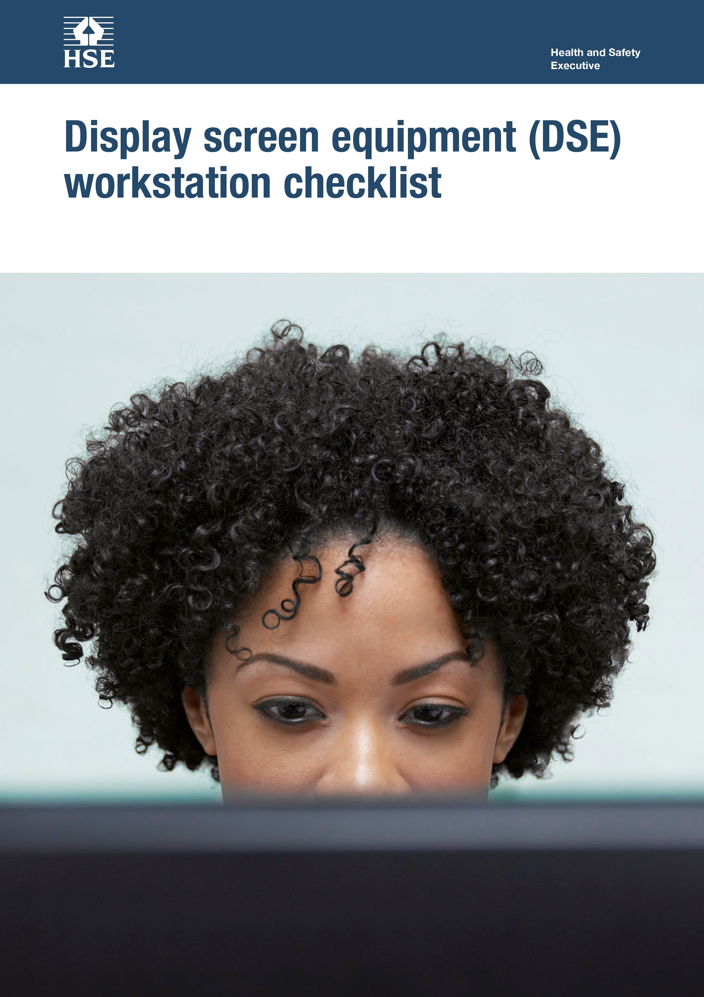

This is a web-friendly version of Display screen equipment (DSE) workstation checklist published 05/13

The following checklist can be used to help you complete a risk assessment and comply with the Schedule to the Health and Safety (Display Screen Equipment) Regulations 1992 as amended by the Health and Safety (Miscellaneous Amendments) Regulations 2002.
Workstation location and number (if applicable):
User: Checklist completed by:
Assessment checked by:
.............................................
.............................................
..............................................
.............................................
Any further action needed: Yes/No
Follow-up action completed on: .............................................

The questions and ‘Things to consider’ in the checklist cover the requirements of the Schedule. If you can answer ‘Yes’ in the second column against all the questions, having taken account of the ‘Things to consider’, you are complying. You will not be able to address some of the questions and ‘Things to consider’, eg on reflections on the screen, or the user’s comfort, until the workstation has been installed. These will be covered in the risk assessment you do once the workstation is installed.

Work through the checklist, ticking either the ‘Yes’ or ‘No’ column against each risk factor:

- ‘Yes’ answers require no further action.
- ‘No’ answers will require investigation and/or remedial action by the workstation assessor. They should record their decisions in the ‘Action to take’ column. Assessors should check later that actions have been taken and have resolved
the problem.

Remember, the checklist only covers the workstation and work environment. You also need to make sure that risks from other aspects of the work are avoided, eg by giving users health and safety training, and providing for breaks or changes of activity. For more advice on these see Working with display screen equipment (DSE): A brief guide.

1

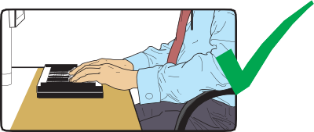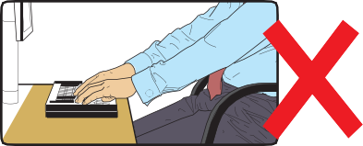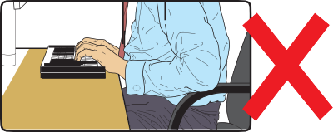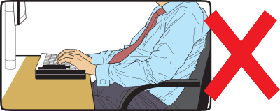Display screen equipment (DSE) workstation checklist

Risk factors | Tick answer |  | Things to consider | Action to take
 | Yes | No
1 Keyboards
Is the keyboard separate from the screen? |  |  | This is a requirement, unless the task makes it impracticable (eg where there is a need to use a portable).
Does the keyboard tilt? |  |  | Tilt need not be built in
Is it possible to find a comfortable keying position? |  |  | Try pushing the display screen further back to create more room for the keyboard, hands and wrists.  Users of thick, raised keyboards may need a wrist rest.
Does the user have good keyboard technique? |  |  | Training can be used to prevent:  - hands bent up at the wrist;  - hitting the keys too hard;  - overstretching the fingers.
Are the characters clear and readable? |  |  | Keyboards should be kept clean. If characters still can’t be read, the keyboard may need modifying or replacing.  Use a keyboard with a matt finish to reduce glare and/or reflection.
2

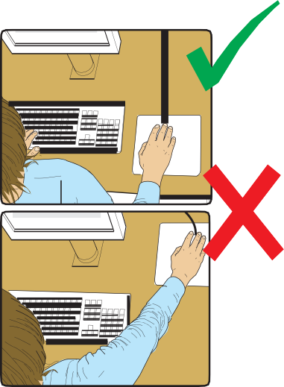Display screen equipment (DSE) workstation checklist

Risk factors | Tick answer |  | Things to consider | Action to take
 | Yes | No
2 Mouse, trackball etc
Is the device suitable for the tasks it is used for? |  |  | If the user is having problems, try a different device. The mouse and trackball are general-purpose devices suitable for many tasks, and available in a variety of shapes and sizes. Alternative devices such as touch screens may be better for some tasks (but can be worse for others).
Is the device positioned close to the user? |  |  | Most devices are best placed as close as possible, eg right beside the keyboard.  Training may be needed to:  - prevent arm overreaching;  - encourage users not to leave their hand on the device when it is not being used;  - encourage a relaxed arm and straight wrist.
Is there support for the device user’s wrist and forearm? |  |  | Support can be gained from, for example, the desk surface or arm of a chair. If not, a separate supporting device may help.  The user should be able to find a comfortable working position with the device.
Does the device work smoothly at a speed that suits the user? |  |  | See if cleaning is required (eg of mouse ball and rollers).  Check the work surface is suitable. A mouse mat may be needed.
Can the user easily adjust software settings for speed and accuracy of pointer? |  |  | Users may need training in how to adjust device settings.

3

Display screen equipment (DSE) workstation checklist

Risk factors | Tick answer |  | Things to consider | Action to take
 | Yes | No
3 Display screens
Are the characters clear and readable?  Health and safety  Health and safety |  |  | Make sure the screen is clean and cleaning materials are available.  Check that the text and background colours work well together.
Is the text size comfortable to read? |  |  | Software settings may need adjusting to change text size.
Is the image stable, ie free of flicker and jitter? |  |  | Try using different screen colours to reduce flicker, eg darker background and lighter text.  If there are still problems, get the set-up checked, eg by the equipment supplier.
Is the screen’s specification suitable for its intended use? |  |  | For example, intensive graphic work or work requiring fine attention to small details may require large display screens.
Are the brightness and/or contrast adjustable? |  |  | Separate adjustment controls are not essential, provided the user can read the screen easily at all times.
Does the screen swivel and tilt?  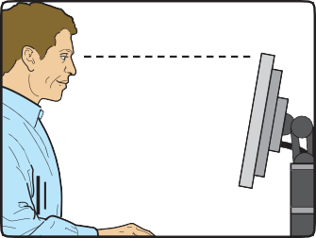 |  |  | Swivel and tilt need not be built in; you can add a swivel and tilt mechanism.  However, you may need to replace the screen if:  - swivel/tilt is absent or unsatisfactory;  - work is intensive; and/or  - the user has problems getting the screen to a comfortable position.
4

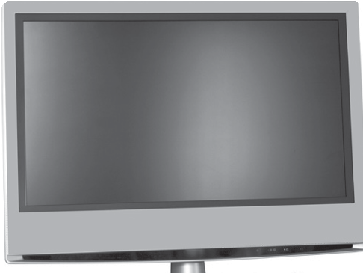Display screen equipment (DSE) workstation checklist

Risk factors | Tick answer |  | Things to consider | Action to take
 | Yes | No
Is the screen free from glare and reflections? |  |  | Use a mirror placed in front of the screen to check where reflections are coming from.  You might need to move the screen or even the desk and/or shield the screen from the source of the reflections.  Screens that use dark characters on a light background are less prone to glare and reflections.
Are adjustable window coverings provided and in adequate condition? |  |  | Check that blinds work. Blinds with vertical slats can be more suitable than horizontal ones.  If these measures do not work, consider anti-glare screen filters as a last resort and seek specialist help.
4 Software
Is the software suitable for the task? |  |  | Software should help the user carry out the task, minimise stress and be user-friendly.  Check users have had appropriate training in using the software.  Software should respond quickly and clearly to user input, with adequate feedback, such as clear help messages.

5

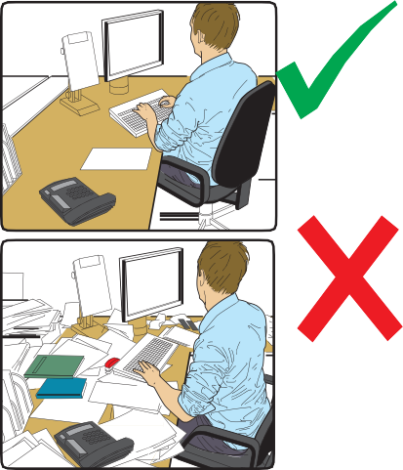Display screen equipment (DSE) workstation checklist

Risk factors | Tick answer |  | Things to consider | Action to take
 | Yes | No
5 Furniture
Is the work surface large enough for all the necessary equipment, papers etc? |  |  | Create more room by moving printers, reference materials etc elsewhere.  If necessary, consider providing new power and telecoms sockets, so equipment can be moved.  There should be some scope for flexible rearrangement.
Can the user comfortably reach all the equipment and papers they need to use? |  |  | Rearrange equipment, papers etc to bring frequently used things within easy reach.  A document holder may be needed, positioned to minimise uncomfortable head and eye movements.
Are surfaces free from glare and reflection? |  |  | Consider mats or blotters to reduce reflections and glare.
Is the chair suitable? Is the chair stable?  Does the chair have a working:  - seat back height and tilt adjustment?  - seat height adjustment?  - castors or glides? |  |  | The chair may need repairing or replacing if the user is uncomfortable, or cannot use the adjustment mechanisms.

6

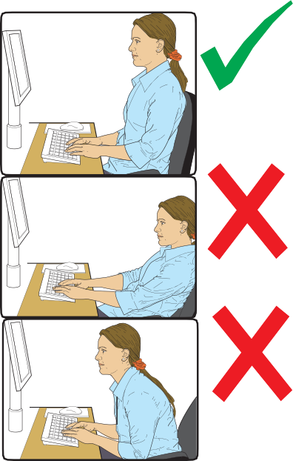Display screen equipment (DSE) workstation checklist

Risk factors | Tick answer |  | Things to consider | Action to take
 | Yes | No
Is the chair adjusted correctly? |  |  | The user should be able to carry out their work sitting comfortably.  Consider training the user in how to adopt suitable postures while working.  The arms of chairs can stop the user getting close enough to use the equipment comfortably.  Move any obstructions from under the desk.
Is the small of the back supported by the chair’s backrest? |  |  | The user should have a straight back, supported by the chair, with relaxed shoulders.
Are forearms horizontal and eyes at roughly the same height as the top of the DSE? |  |  | Adjust the chair height to get the user’s arms in the right position, and then adjust the DSE height, if necessary.
Are feet flat on the floor, without too much pressure from the seat on the backs of the legs? |  |  | If not, a footrest may be needed.

7

Display screen equipment (DSE) workstation checklist

Risk factors | Tick answer |  | Things to consider | Action to take
 | Yes | No
6 Environment
Is there enough room to change position and vary movement? |  |  | Space is needed to move, stretch and fidget.  Consider reorganising the office layout and check for obstructions.  Cables should be tidy and not a trip or snag hazard.
Is the lighting suitable, eg not too bright or too dim to work comfortably? |  |  | Users should be able to control light levels, eg by adjusting window blinds or light switches.  Consider shading or repositioning light sources or providing local lighting, eg desk lamps (but make sure lights don’t cause glare by reflecting off walls or other surfaces).
Does the air feel comfortable? |  |  | DSE and other equipment may dry the air.  Circulate fresh air if possible. Plants may help.  Consider a humidifier if discomfort is severe.
Are levels of heat comfortable? |  |  | Can heating be better controlled? More ventilation or air conditioning may be required if there is a lot of electronic equipment in the room. Or, can users be moved away from the heat source?
Are levels of noise comfortable? |  |  | Consider moving sources of noise, eg printers, away from the user. If not, consider soundproofing.

8

Display screen equipment (DSE) workstation checklist

7 Final questions to users...

- Has the checklist covered all the problems they may have working with their DSE?
- Have they experienced any discomfort or other symptoms which they attribute to working with their DSE?
- Has the user been advised of their entitlement to eye and eyesight testing?
- Does the user take regular breaks working away from DSE?
Write down the details of any problems here:

9

Display screen equipment (DSE) workstation checklist

Further information
Working with display screen equipmemt (DSE): A brief guide Leaflet INDG36(rev4) HSE books 2013 www.hse.gov.uk/pubns/indg36.htm

For information about health and safety visit https://books.hse.gov.uk or http://www.hse.gov.uk. You can view HSE guidance online and order priced publications from the website. HSE priced publications are also available from bookshops.

To report inconsistencies or inaccuracies in this guidance email: commissioning@wlt.com

British Standards can be obtained in PDF or hard copy formats from BSI: http://shop.bsigroup.com or by contacting BSI Customer Services for hard copies only Tel: 0846 086 9001 Email: mailto:cservices@bsigroup.com
The Stationery Office publications are available from The Stationery Office, PO Box 29, Norwich NR3 1GN Tel: 0333 202 5070 Fax: 0333 202 5080.
Email: customer.services@tso.co.uk Website: http://www.tso.co.uk. They are
also available from bookshops.

Statutory Instruments can be viewed free of charge at http://www.legislation.gov.uk where you can also search for changes to legislation.

© Crown copyright 2013

First published 2013

ISBN 978 0 7176 6521 1

You may reuse this information (excluding logos) free of charge in any format or medium, under the terms of the Open Government Licence. To view the licence visit www.nationalarchives.gov.uk/doc/open-government-licence/, write to the Information Policy Team, The National Archives, Kew, London TW9 4DU, or email psi@nationalarchives.gsi.gov.uk.

Some images and illustrations may not be owned by the Crown so cannot be reproduced without permission of the copyright owner. Enquiries should be sent to copyright@hse.gsi.gov.uk.

This guidance is issued by the Health and Safety Executive. Following the guidance is not compulsory, unless specifically stated, and you are free to take other action. But if you do follow the guidance you will normally be doing enough to comply with the law. Health and safety inspectors seek to secure compliance with the law and may refer to this guidance.

10

QCS
Regus House, Highbridge Industrial Estate, Oxford Road, Uxbridge, Middlesex, UB8 1HR, United Kingdom, Phone: TBA
Page: 1 of 2 Printed: 16/03/2020

ACAS Home Working Checklist - GPC19

Action Completed
(insert date & notes)
Employer to make sure employee has a suitable area at home to work
Employer to make sure employee has/is provided with:
- Furniture
- Phone
- IT
- Adequate internet connection
- Fire extinguisher
Employee to check home insurance covers home working and a claim from a third party
Employer to check its insurance covers business equipment in the homeworker’s home and a claim from a third party
Employer to carry out a health and safety risk assessment
Employee to tell their mortgage provider/landlord of their plan to work from home and to check they are allowed to under their mortgage or rent agreement
Employee to check if business rates will have to be paid
Employee to check if planning permission is necessary

1

2

3

4

5

6

7

8

Continued on next page

QCS
Regus House, Highbridge Industrial Estate, Oxford Road, Uxbridge, Middlesex, UB8 1HR, United Kingdom, Phone: TBA
Page: 2 of 2 Printed: 16/03/2020

ACAS Home Working Checklist - GPC19

Action Completed
(insert date & notes)
Employer and employee to agree keeping in touch through, for example:
- Phone/Skype®/email/ Microsoft Teams
- Planned meetings at the main office/base
- Planned meetings at the homeworker’s home
- Co-operation with colleagues
Employer and employee to agree how often the employee will attend the main base/office
Employer and employee to agree how performance will be monitored and managed
Employer and employee to agree any arrangements for claiming expenses, what can be claimed, how, when and what is taxable
Employer and employee to agree how often the home working arrangement will be reviewed, and when and where review meetings will be held – if a trial period has been agreed, when that will be assessed, and what will happen if it doesn’t work out
Employer to put arrangements in writing and/or issue a home working policy
Employer to compile a consent form. Employer and employee to sign it to show details of the home working arrangement have been agreed
Employer to amend the employee’s contract to reflect the home working agreement
Employer to check IT support is in place including what will be provided by whom, when and how

9

10

11

12

13

14

15

16

17

Home Working Risk Assessment – Home worker Completion Template

What are the hazards? | Risk | How might this cause harm? | Who might be Harmed  ? | What are you already doing? | Employee Comments | Confirmation |  | Risk Rating  - High  - Mediu m  - Low
 |  |  |  |  |  | Yes | No
Electrical Hazards | - Electrical system in poor condition  - damaged sockets or wiring)?  - Insufficient Sockets- Overloaded electrical sockets  - Faults on existing portable electrical  equipment? | - Electric Shock and Burns  - Fire  - Damage to Equipment | Home worker | - Staff advised that electricity supply and any electrical appliances used while homeworking must be well maintained and regularly checked  - Staff advised to use circuit breakers for electrical appliances and not to overload sockets  - Staff advised to visually inspect electrical equipment and to use electrical items from a reliable source with CE mark visible | - I have visually checked electrical items  - I confirm sockets are not overloaded  - I have used a circuit breaker
Unsafe Environment | - Insufficient  task lighting  - Glare on the monitor from Windows or Lights | - Eye Strain  - Headaches |  | - Use additional task lighting  - If windows cause glare, curtains or blinds are closed  - Staff advised to adjust window coverings as the sun shifts during the day  - Tilt or swivel the screen so the light doesn't shine on the screen. Antiglare filters for the screen may also help  - Adjust both contrast and brightness on the computer | - I can close curtains or shutters if required to reduce glare  - I can adjust my monitor/screen to reduce glare  - I know how to adjust the setting on my computer

What are the hazards? | Risk | How might this cause harm? | Who might be Harmed  ? | What are you already doing? | Employee Comments | Confirmation |  | Risk Rating  - High  - Mediu m  - Low
 |  |  |  |  |  | Yes | No
Manual handling | - Moving/carryi ng your laptop and setting up your homeworking area | - Musculoskeletal strain or injury, particularly to the back. |  | - Avoid heavy, bulky loads or materials; Avoid steps and steep ramps  - When lifting is necessary, staff are informed, instructed and trained in good techniques to help reduce the risks. | - I can easily reach everything that I need without twisting and straining my back. I take regular breaks away from my workstation  - I carry out regularly stretches at my desk to avoid stiff or sore muscles  - I sit with a good posture and I am not hunched over the desk  - I have easy access to first aid equipment if required  - I have a table/desk and a suitable chair to work for long periods of time on
Slips, Trips and Falls | - Trip on loose carpets, rugs  - Falls due to unsafe footwear  - Cluttered floor space  - Poor lighting  - Trailing electrical cables | - Physical injury |  | Staff instructed to  - Keep work areas tidy and clear of obstructions or objects lying around that may cause person to trip  - Clean up spills straightaway  - Arrange furniture in order to avoid trailing wires  - Ensure rugs and carpets are securely fixed and do not have curling edges  - Ensure suitable footwear e.g. not loose slippers  - Ensure enough lighting | - I keep the floor free from clutter and trip hazards  - I understand the importance of safe manual handling  - I will report/make any repairs necessary to my home working environment

What are the hazards? | Risk | How might this cause harm? | Who might be Harmed  ? | What are you already doing? | Employee Comments | Confirmation |  | Risk Rating  - High  - Mediu m  - Low
 |  |  |  |  |  | Yes | No
Display Screen Equipment | - Eyestrain, headaches, joint pain, muscle stiffness, repetitive strain injury | - Musculoskeletal upper limb disorders, for example back pain, and upper limb disorders, visual fatigue and stress | Home worker | - Staff must read the Display Screen Equipment Policy and Procedure and there is evidence in the QCS system that they have done so  - Staff work through the DSE Checklist within the policy and return this completed for record keeping | - The screen image is clear and stable with no flickering, and can it be tilted and swiveled  - The screen text is a comfortable size to read  - The brightness and contrast are easily adjustable and suitable for ambient lighting  - The screen is free from glare and reflections  - Binds/Curtains in place to minimise glare and reflections and they are effective  - The screen is positioned as far away as possible while still being able to be read clearly  - The mouse or track ball is suitable for the task  - The mouse or track ball work smoothly and at a suitable speed  - There is enough space to rest hands comfortably in front of the keyboard  - The keyboard is comfortable to use  - The keyboard is tiltable and separate from the screen

What are the hazards? | Risk | How might this cause harm? | Who might be Harmed  ? | What are you already doing? | Employee Comments | Confirmation |  | Risk Rating  - High  - Mediu m  - Low
 |  |  |  |  |  | Yes | No
Display Screen Seating | - Neck pain , hip pain, back pain, repetitive strain injury | - Musculoskeletal upper limb disorders, for example, back pain, and upper limb disorders, visual fatigue and stress |  | - Staff must read the Display Screen Equipment Policy and Procedure and there is evidence in the QCS system that they have done so  - Staff work through the DSE Checklist within the policy and return this completed for record keeping | The chair and screen can be adjusted so:  - The top line of the screen is no higher than eye level  - The user’s head is level, back is straight and lower back is comfortably supported  - Forearms are parallel with the floor and wrists are straight  - Feet rest on the floor without pressure on the back of the legs  - Is a footrest required?  - Is a document holder required?  - Is a wrist rest required?
Isolation and Security | - Stress, depression, decrease in wellbeing, security and safety due to lone working | - Stress, depression, decrease in wellbeing, violence, aggression from strangers |  | - Regular contact between company and home worker  - Information and support for homeworkers the same as for as on-site workers, including information on social events  - Homeworkers encouraged to take regular breaks  - Encouraged to exercise and eat healthily  - Encouraged to follow regular work pattern to separate work from home  - Staff reminded to follow the Lone Working Policy and not invite strangers into the home | - I keep in contact with the workplace and colleagues  - I understand the importance of regular breaks  - I have read and understood the Lone Working Policy  - I understand I can discuss with my manager if I feel that home working is having a negative impact on my wellbeing

What are the hazards? | Risk | How might this cause harm? | Who might be Harmed  ? | What are you already doing? | Employee Comments | Confirmation |  | Risk Rating  - High  - Mediu m  - Low
 |  |  |  |  |  | Yes | No
Wellbeing | - Eyestrain, headaches, joint pain, muscle stiffness, repetitive strain injury | Musculoskeletal upper limb disorders, for example, back pain, and upper limb disorders, visual fatigue and stress |  | - Staff must read the Display Screen Equipment Policy and Procedure and there is evidence in the QCS system that they have done so  - Staff work through the DSE Checklist within the policy and return this completed for record keeping | - I take regular breaks away from my workstation  - I carry out regularly stretches at my desk to avoid stiff or sore muscles  - I sit with a good posture and I am not hunched over the desk  - I have easy access to first aid equipment if required  - I have my eyes tested every year  - I have a table/desk and a suitable chair to work for long periods of time on

Completed by
Authorised by
Date
Risks Rating
Actions Completed | Date |  | Yes | No
Comments/Actions Required

Guidance

Workplace health and safety law applies to homeworkers and we have the same legal duty to protect your health, safety and welfare, as if you were working on the premises. Under the Management of Health and Safety at Work Regulations, we are required to assess the risk of work activities carried out by staff who work at home. In most cases the risk assessment can be carried out by the homeworker. Completing a risk assessment involves identifying the hazards relating to work activities carried out in the home environment and deciding whether appropriate steps (control measures) have been taken to prevent harm to them or to anyone else who may be affected by their work. A risk assessment will:
  - Identify hazards (a hazard is anything that may cause harm)
  - Decide who might be harmed and how
  - Assess the risks (a risk is the chance, great or small, that someone will be harmed by a hazard) and take appropriate action to remove them or reduce (control) them as far as possible
  - Record the findings; and
  - Be reviewed from time to time to see whether take further steps if needed
Before home working starts, the risk assessment must be completed and passed to the line manager: the line manager must be satisfied that there is low risk and that any additional control measures are in place. Both the employee and the manager must retain a copy of the risk assessment, which must be reviewed at regular intervals.

