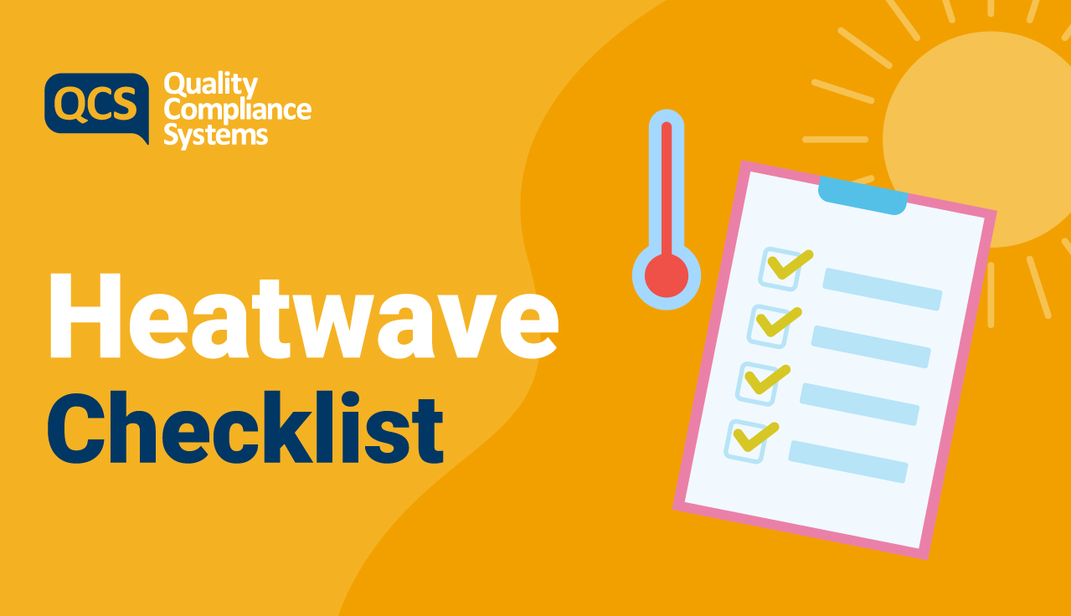

This checklist will outline the key elements to consider and review during a heatwave.

Checkpoint | Yes | No | N/A | Comments
Are local weather forecasts regularly monitored by the service? | ☐ | ☐ | ☐ | Click or tap here to enter text.
Are all staff familiar with the Heatwave Policy and Procedure? | ☐ | ☐ | ☐ | Click or tap here to enter text.
Are staff trained in the signs and effects of a heatwave? | ☐ | ☐ | ☐ | Click or tap here to enter text.
A robust Business Continuity Plan is in place that encompasses heatwave considerations? | ☐ | ☐ | ☐ | Click or tap here to enter text.
Sufficient staffing levels are in place? | ☐ | ☐ | ☐ | Click or tap here to enter text.

Environment/Facilities | Yes | No | N/A | Comments
Are windows that are exposed to direct sunlight shaded or covered? | ☐ | ☐ | ☐ | Click or tap here to enter text.
Are windows accessible to open where required, whilst acknowledging security considerations? | ☐ | ☐ | ☐ | Click or tap here to enter text.
Are windows or vents opened when the air feels cooler outside than inside? | ☐ | ☐ | ☐ | Click or tap here to enter text.
Is the central heating system turned off? | ☐ | ☐ | ☐ | Click or tap here to enter text.
Are lights and electrical equipment turned off when not in use? | ☐ | ☐ | ☐ | Click or tap here to enter text.
Are indoor thermometers in place? | ☐ | ☐ | ☐ | Click or tap here to enter text.
Are indoor temperatures regularly monitored? | ☐ | ☐ | ☐ | Click or tap here to enter text.
Is there an adequate supply of fans at the service? | ☐ | ☐ | ☐ | Click or tap here to enter text.
Are there adequate supplies of cold drinks, water, and ice at the service? | ☐ | ☐ | ☐ | Click or tap here to enter text.
Are menus adapted, during a heatwave, to support colder meals during hot weather? | ☐ | ☐ | ☐ | Click or tap here to enter text.

Service Users | Yes | No | N/A | Comments
Is there a current list in place of service users most at risk due to the heat? | ☐ | ☐ | ☐ | Click or tap here to enter text.
Are protocols in place to monitor the most at risk service users? | ☐ | ☐ | ☐ | Click or tap here to enter text.
Where required, have service users’ GPs been contacted about possible changes to their treatment and/or medication? | ☐ | ☐ | ☐ | Click or tap here to enter text.
Do service users have light, loose-fitting clothing to wear? | ☐ | ☐ | ☐ | Click or tap here to enter text.
Do staff monitor for changes in behaviour of service users? | ☐ | ☐ | ☐ | Click or tap here to enter text.

Service Users | Yes | No | N/A | Comments
Are service users encouraged to remain in the coolest parts of the building, where possible? | ☐ | ☐ | ☐ | Click or tap here to enter text.
Is the fluid intake of service users monitored? | ☐ | ☐ | ☐ | Click or tap here to enter text.
Are service users advised to avoid caffeine, very sweet drinks, and alcohol? | ☐ | ☐ | ☐ | Click or tap here to enter text.
Where required, are showers or cool baths arranged for service users? | ☐ | ☐ | ☐ | Click or tap here to enter text.

