Topical Cream Administration Record |  |  | Sheet |  | Of |  | Start date:
Photo | Name: |  |  |  | GP Name
 | Date of Birth: |  |  |  | Surgery
 | Address: |  |  |  | NHS No.
 | Allergies:
 | Key: | R = Refused, H = Hospital, N = Nausea / Vomit, X = Not Given, O = Other
Medication Details
Highlight below where cream is to be administered
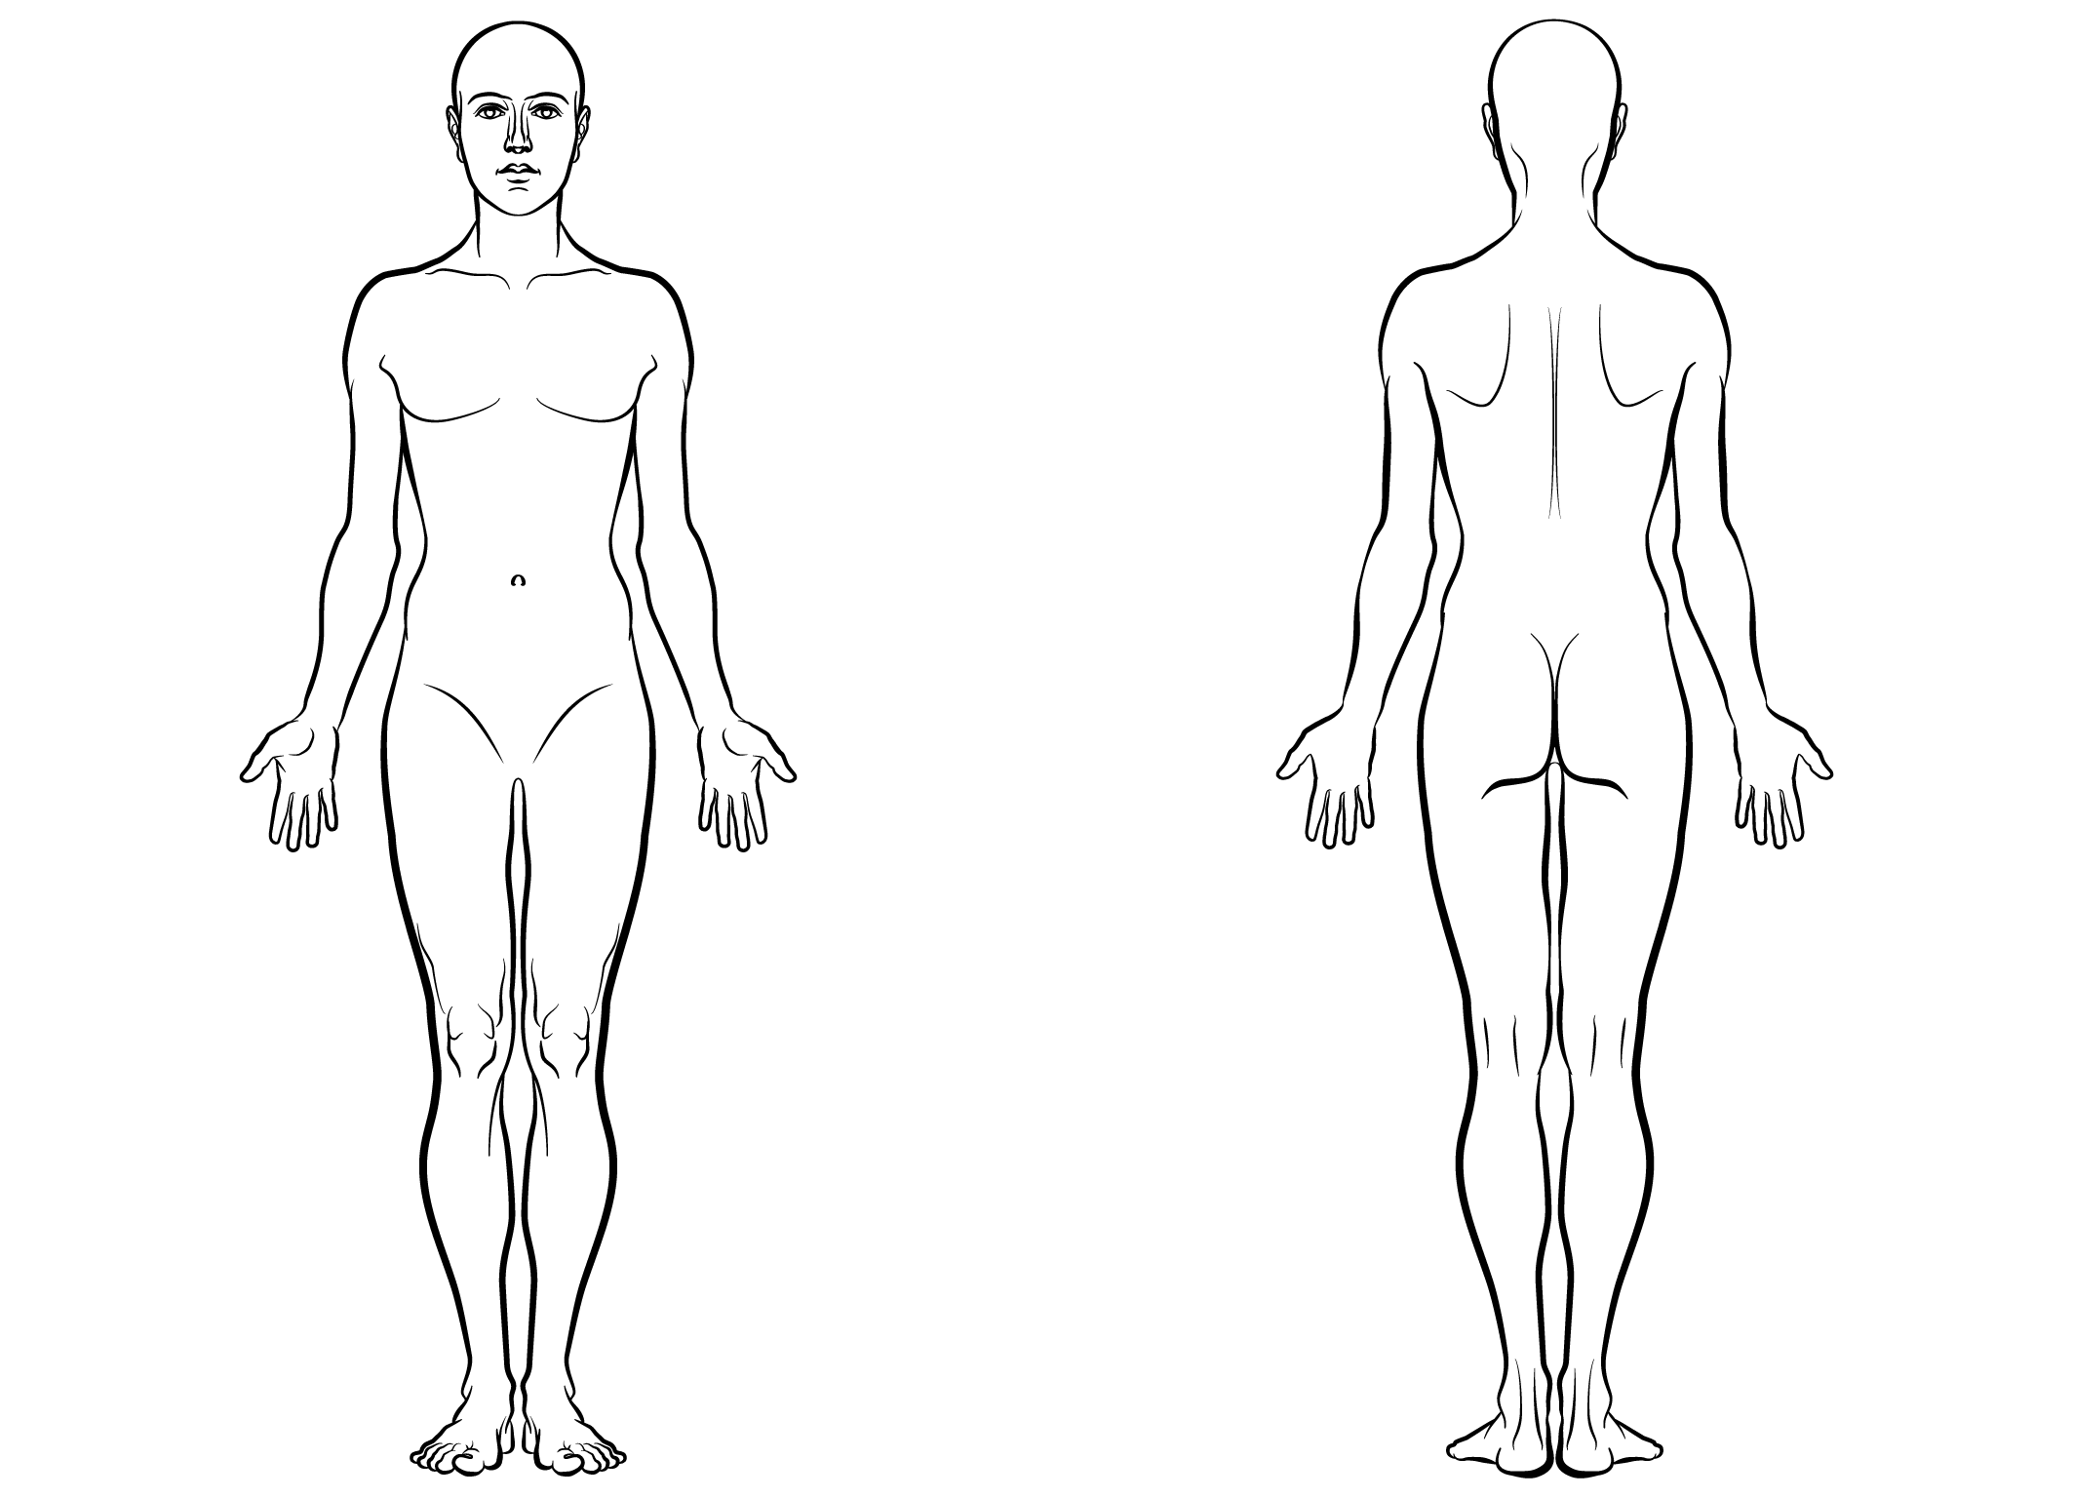

 | Week 1 |  |  |  |  |  |  |  |  | Week 2 |  |  |  |  |  |  |  |  |  | Week 3 |  |  |  |  |  |  |  |  | Week 4
Date
Morning
Lunch
Tea
Bed
Completed |  | Approved |  |  |  |  | Quantity received: |  |  |  |  |  |  |  |  |  |  | Carried forward: |  |  |  |  |  |  |  |  |  |  |  | Returned:
by |  | by |  |  |  |  | Sign |  |  |  |  | Date |  |  |  |  |  | Sign |  |  |  |  |  |  |  |  |  | Date

Date | Time | Detail of Notes | Name: | Sign:

